**SENSOR AND MEASUREMENT – PRACTICE**

**PRACTICE REPORT WEEK 8 – GROUP 8 NGUYỄN TIẾN NHẬT**

**MSSV:1613133**

**CHAPTER 7: PT-100 TEMPERATURE SENSOR**

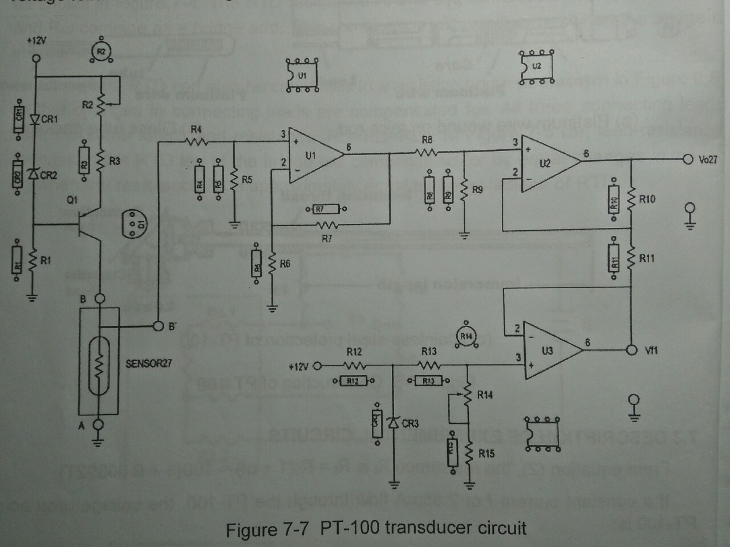

**I)R vs. T characteristic of PT-100**

1. **The resistance of the PT-100 is proportional to the temperature**

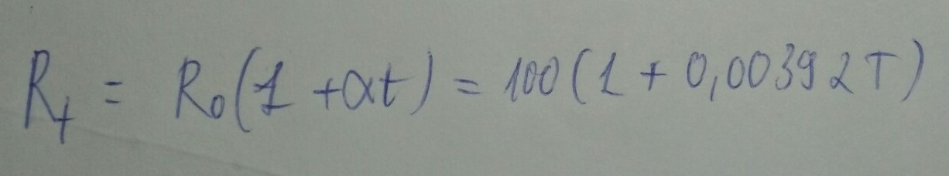

**2. Using the above equation to calculate and record the resistance Rt for each temperature setting on Table 7-1:**

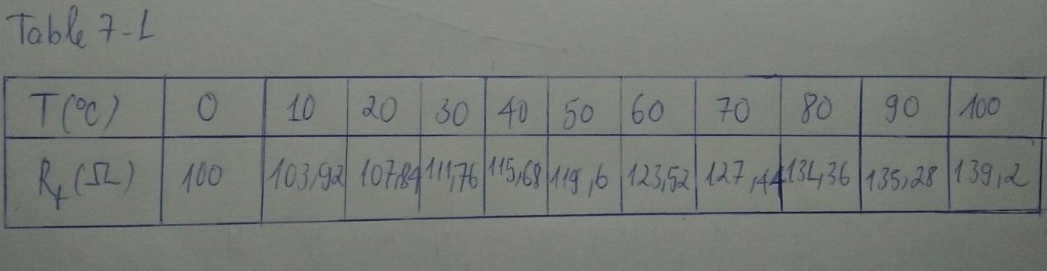

**3. Adjust the thermostat to PT-100 by temperature regulator. Measure and record the resistance and temperature several times during the temperature rising, and then complete Table 7-2:**

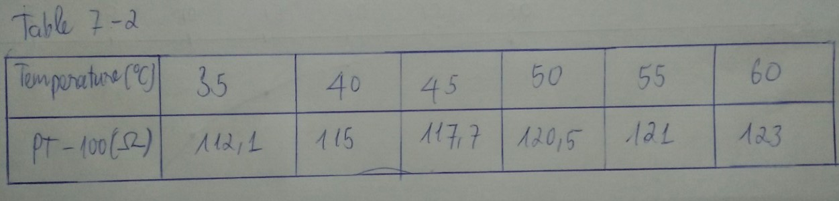

**4) Compare the data in Table 7-1 with those in Table 7-2:**

* **Comment: we can see that from the table (7-1 and 7-2), resistance value recorded during the temperature rising,approximately with the proportion of those calculated in sections 1 and 2.**

**II) TRANSDUCTION CIRCUIT**

1. **Adjust the thermostat to PT-100 by temperature regulator. Measure and record the output voltage of PT-100 at Vo27 for each temperature setting on Table 7-3:**

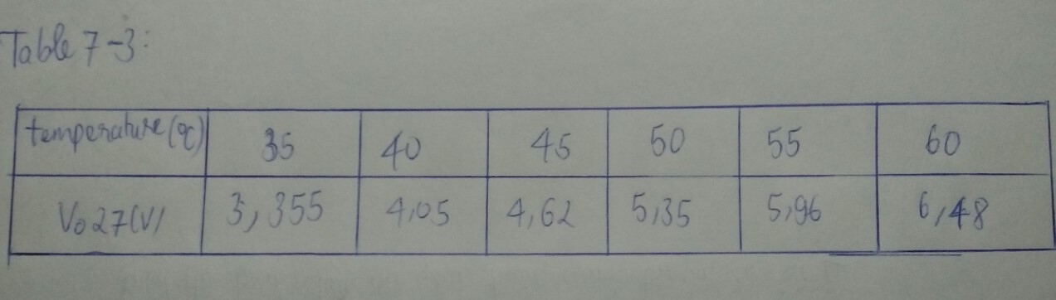

1. **Plot a V vs. T characteristic curve of the PT-100 transducer using data from the above table:**

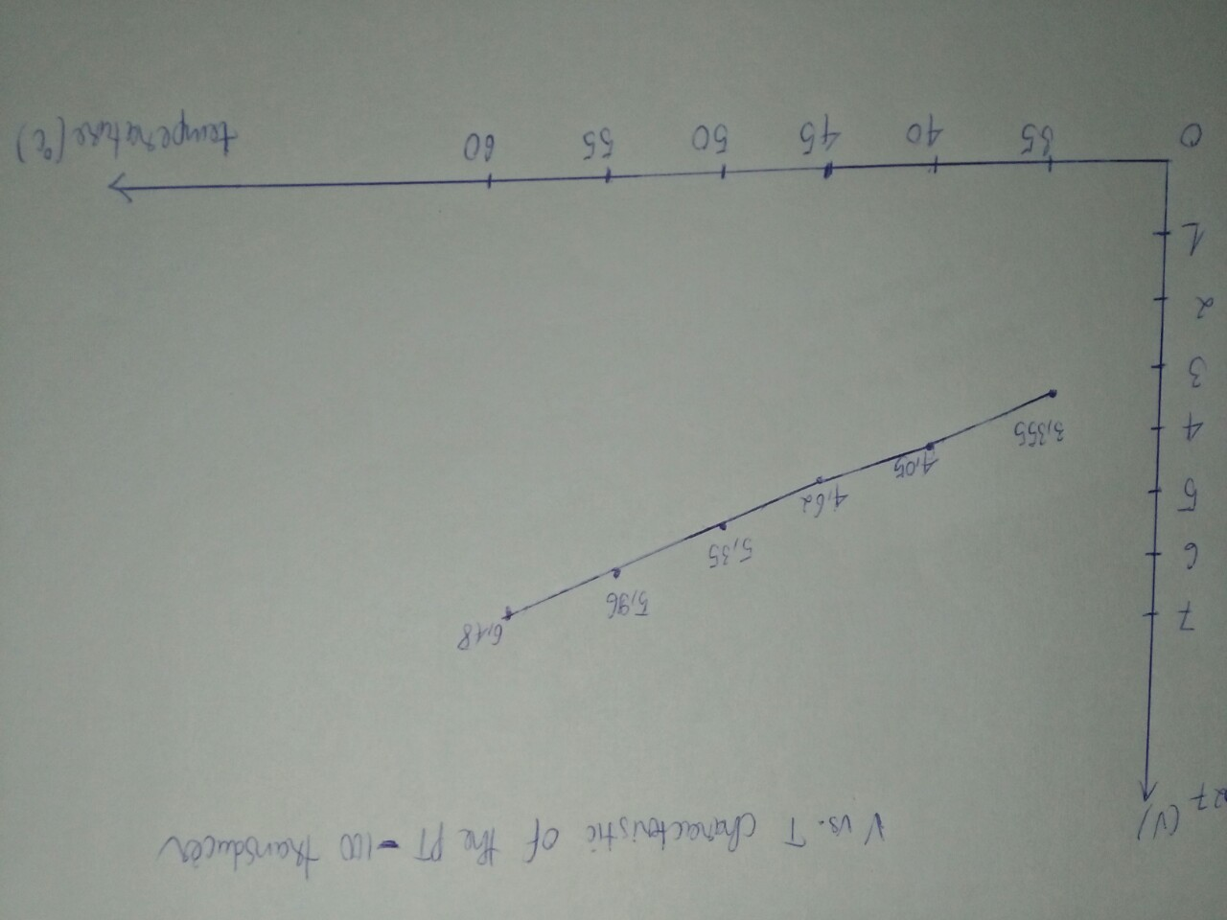

1. **Observe the curve in step 2, calculate and record the transuction ratio:**

**≈ 146 (mV)**